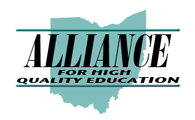
2017-2018 ALLIANCE LEGISLATIVE COMMITTEE MEETINGS
Monthly Executive Committee meetings are as follows (2nd Wednesday of the month) unless
otherwise noted:
2017
October Wednesday, October 11th, 10:00 a.m., BASA conference room
November Wednesday, November 8th, 10:00 a.m., BASA conference room
December Wednesday, December 13th, 10:00 a.m., BASA conference room
* * *
November Monday, November 13th –– Annual Meeting & Luncheon at OSBA
Capital Conference
* * *
2018
January Wednesday, January 10th, 10:00 a.m., BASA conference room
February Wednesday, February 14th, 10:00 a.m., BASA conference room
March Wednesday, March 14th, 10:00 a.m., BASA conference room
April Wednesday, April 11th, 10:00 a.m., BASA conference room
May Wednesday, May 9th, 10:00 a.m., BASA conference room
June Wednesday, June 13th, 10:00 a.m., BASA conference room
July Wednesday, July 11th 10:00 a.m., BASA conference room
August NO MEETING

